Instructions and Template for the Abstract of the Special Presentation by Students of College of Technology and High School

(Microsoft WORD)

Author1*, Author2**, Author3* and Author4**

*Department of Engineering, Kindai University, Osaka, Japan
**Department of Bioengineering, Kindai University, Wakayama, Japan

Abstract

Before you start preparing your paper, save this file as a standard (.doc extension) WORD document and name it using the First author's full name. For example: Taro-OSAKA.doc. Set all the margins to be 25.4 mm and the paper size to A4 to get the correct page layout.
Abstract should be submitted electronically on website before the June 30th, 2016 deadline. Microsoft Word (.doc) and PDF (.pdf) files should be provided via an e-mail (ei@waka.kindai.ac.jp). Abstract must use the guidelines provided in this template. The length of abstract is limited to only 1 page.
One-page abstract should have the title of paper, names and affiliations of authors. The abstract can contain figures, tables, equations, and references, but page excess is not allowed. Use the Times New Roman font and single line spacing for all. Use the 16 pt for title, the 14 pt for names and affiliations of authors and the 12 pt for main text. For affiliations of authors, use the Italic Times New Roman font.
Please fully utilize the entire page for abstract (i.e., do not leave a large blank space).

Keywords: Experimental Mechanics, Advanced Science, Flow Visualization, Optical Method, X-ray Techniques

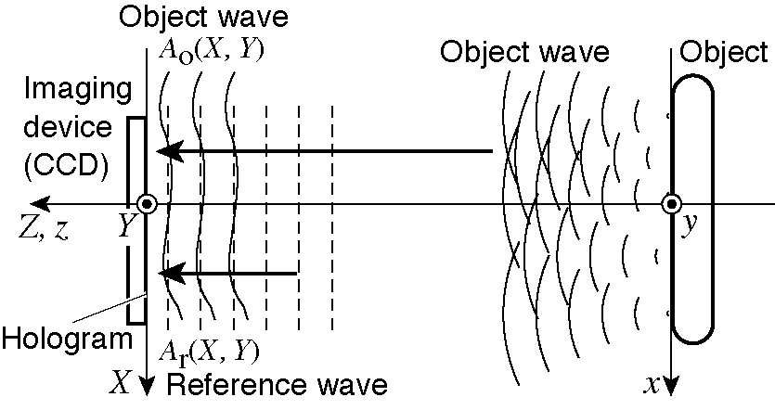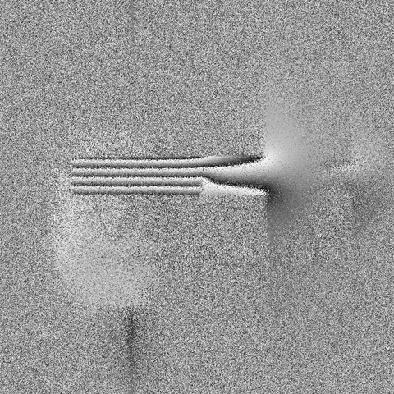
(a) Principle (b) Phase difference
Fig. 1. These are samples

