Instructions for Authors for Preparation of Full Manuscript

Satoru OKAMOTO¹ and Ichiro SHIMIZU²
¹ Interdisciplinary Graduate School of Science and Engineering, Shimane University, Matsue 690-8504, Japan
² Department of Mechanical Engineering, Okayama University of Science, Okayama 700-0005, Japan

Abstract: This template explains and demonstrates how to prepare your manuscript for 2019 ISEM Proceedings. Authors are strongly advised to read these instructions to rigorously follow the outline of this text. Please use Times New Roman 10 pt in the main body of a text. Note that abstract should not exceed 10 lines.

Keywords: Camera-Ready Copy, Electronic Data, Manuscript Format, Reference Style (minimum 4 words)

1. Introduction
All manuscripts must be written in English including tables and figures. When receiving the manuscript, we assume that the corresponding authors grant us the right to use the manuscript for 2019 ISEM Proceedings. Should authors use tables or figures from other publications, they must obtain the rights from the corresponding publishers for publishing this material in their manuscript.
The overall length of the manuscript, including Figures and Tables, must be less than 6 pages. The typing area must be 176mmx245mm. Type the text single-sided and single-spaced in two columns.
New paragraphs should have an indent of 3 columns. This MS-Word document can be used as a template. The PDF file of your manuscript should be submitted online at the Symposium website (http://www.jsem.jp/ISEM14). The file size should not exceed 10 MByte. The title of the PDF file should include your receipt number (3 digits) and the first author’s full name (Example: 012-Taro-YAMADA.pdf). “Receipt number” will be given in the acceptance e-mail of 14th ISEM abstract.
If you have any inquiry, please contact:
Prof. Hideaki Monji (University of Tsukuba)
Tel : +81-29-853-5061 Fax: +81-29-853-5207
E-mail: monji@kz.tsukuba.ac.jp

Heading categories
- Main Sections (type in bold capitals)
- Sub-headings (type in bold lower case)
- Sub-subheadings (type in italic lower case)

2. Organization of the Text
A short abstract not more than 10 lines should state briefly the aim, methods and results as a paragraph. Define abbreviations and acronyms the first time they are used. Footnotes should be avoided wherever possible.

2.1 Structure of manuscript
Manuscripts should have the following structure: Title, Name(s) of author(s) and affiliation, Abstract, Main Text, Conclusion(s), Nomenclature, Acknowledgement(s) (if any), References, Appendix (if any).

2.1.1 Formatting
For formatting the page for an A4-sized manuscript, set top margin at 22mm and bottom margin at 28mm; and left and right margins at 17mm. The column width should be 83mm. The space between the two columns should be 10mm. Justify the both columns.

2.1.2 Fonts
Title: 11-point bold Times New Roman
Author: 10-point Times New Roman
Affiliation: 10-point Times New Roman
Main text: 10-point Times New Roman

2.1.3 Units and equations
All data should be given in SI units. Align each equation to the left, allow single spacing above and below, and ident by 5 mm as follows:

$\frac{{\text{∂}}^{\text{2}}\text{T}}{{\text{∂x}}^{\text{2}} }\text{+ }\frac{{\text{∂}}^{\text{2}}\text{T}}{\text{∂}{\text{y}}^{\text{2}} }\text{ = }\frac{\text{1}}{\text{k}}\frac{\text{∂T}}{\text{∂t}}$$\frac{{\text{∂}}^{\text{2}}\text{T}}{{\text{∂x}}^{\text{2}} }\text{+ }\frac{{\text{∂}}^{\text{2}}\text{T}}{\text{∂}{\text{y}}^{\text{2}} }\text{ = }\frac{\text{1}}{\text{k}}\frac{\text{∂T}}{\text{∂t}}$$\frac{{\text{∂}}^{\text{2}}\text{T}}{{\text{∂x}}^{\text{2}} }\text{+ }\frac{{\text{∂}}^{\text{2}}\text{T}}{\text{∂}{\text{y}}^{\text{2}} }\text{ = }\frac{\text{1}}{\text{k}}\frac{\text{∂T}}{\text{∂t}}$$\frac{{\text{∂}}^{\text{2}}\text{T}}{{\text{∂x}}^{\text{2}} }\text{+ }\frac{{\text{∂}}^{\text{2}}\text{T}}{\text{∂}{\text{y}}^{\text{2}} }\text{ = }\frac{\text{1}}{\text{k}}\frac{\text{∂T}}{\text{∂t}}$ $\frac{{\text{∂}}^{\text{2}}\text{T}}{{\text{∂x}}^{\text{2}} }\text{+ }\frac{{\text{∂}}^{\text{2}}\text{T}}{\text{∂}{\text{y}}^{\text{2}} }\text{ = }\frac{\text{1}}{\text{k}}\frac{\text{∂T}}{\text{∂t}}$ (1)

In the text, equations should be referred to as Eq. (1), Eq. (2), and so on; however, at the beginning of a sentence, the word should be spelled out (Equation (1), Equation (2), and so on ). Equations must be sequentially numbered, and the number should be placed inside parentheses at the right-hand edge of the text.

2.2 Tables
In the text, tables should be referred to as Table 1, Table 2, and so on; they should be presented as part of the text, but in such a way as to avoid confusion with the text. The table captions should be self-contained and placed above each table. Units in tables should be given in square brackets e.g., [mV].

Table 1 Caption of table
Retardation [nm] | Fringe order | Observed color
0 | 0 | Black
400 | 0.73 | Yellow
650 | 1.19 | Blue

2.3 Figures
Figures should be referred to as Fig. 1, Fig. 2, and so on in the text; however, at the beginning of a sentence, the word should be spelled out. Figure should also be presented as part of the text, leaving enough space so that the caption will not be confused with the text. Figure captions should be self-contained and placed below each Figure. Generally, only original drawings or photographic reproductions are acceptable. Half-tone pictures should be in the form of glossy prints. If possible, please include your figures as graphic images in the electronic version. For best quality the pictures should have a resolution of 300 dpi (dots per inch). If possible, please fit figures, tables, and photographs in one column. Do not reduce figures or tables to a size at which their labels will be difficult to read. References are cited in the text using square brackets. Two or more references at a time may be used in one set of brackets; [1, 2] or [3–8]. The reference style for each type of citation is given at the end of this template.

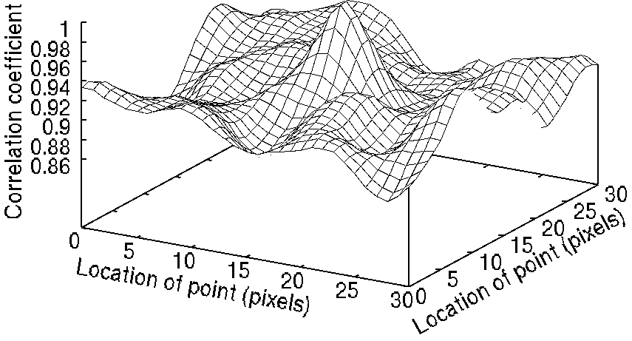

Fig. 1 Relation between correlation coefficient and location of point: note that axis labels should be legible
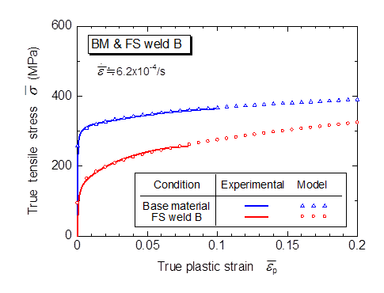

Fig. 2 Comparison between measured true tensile stress-plastic strain curves and Ludwik model predictions for base material and FS weld B: note that axis labels should be legible

3. Conclusions
We can summarize the instructions for authors as follows:
Fig. 11 Comparison between measured true tensile stress-plastic strain curves and Ludwik relations for base material and FS weld B in transverse(T) direction
Fig. 11 Comparison between measured true tensile stress-plastic strain curves and Ludwik relations for base material and FS weld B in transverse(T) direction
1. This template explains and demonstrates how to prepare your manuscript.
2. Authors are strongly advised to read these instructions to rigorously follow the outline of this text as well as the reference styles for citation.

Nomenclature (in alphabetical order)
c_{p} specific heat [J/kgK]
h heat transfer coefficient [W/m²K]
ρ density [kg/m³]
(in Greek alphabetical order )
Subscripts (in alphabetical order )
f surrounding fluid
m mean

Acknowledgement
The support provided by the INOUE Science Promotion Foundation, Tokyo, is gratefully appreciated.

References
[1] Dally, J. W. and Riley W. F.: Experimental Stress Analysis (3rd ed.), McGraw-Hill (1990), 374–388.
[2] Chao, Y. J. and Sutton, M. A.: Accurate measurement of two- and three-dimensional surface deformations for fracture specimens by computer vision, Experimental Techniques in Fracture (Epstein, J.S ed.), VCH Publishers (1993), 59–93.
[3] Frocht, M. M. and Guernsey, Jr.: Further work on the general three-dimensional photoelastic problem, J. Appl. Mech., 22–6 (1995), 183–189.
[4] Ohtaki, S., Matsumoto, N. and Kasayama, H.: Photoelastic coating experiment of perforated plate subjected to biaxial tension, Proc. 12th International Conference on Experimental Mechanics (2004), 10–11.
[5] Rys, T., Chen, L. and Sankar, B.: Mixed mode fracture toughness of laminated stitched composites, CD-ROM Proc. 2004 SEM X International Congress and Exposition on Experimental and Applied Mechanics, (2004).
[6] Sato, Y., Arikawa, S. and Yoneyama, S.: Identification of elastic material characteristics of dissimilar materials by virtual fields method (in Japanese), J. JSEM, 14–24 (2014), 250–256.
[7] Blitterswyk, J. V., Fletcher, L. and Pierron, F.: Characterisation of the interlaminar properties of composites at high strain rates: a review, Adv. Exp. Mech., 2 (2017), 3–28.
[8] Longhurst, W. L.: Force control friction stir welding, PhD Thesis, Vanderbild University, (2009).
[9] ImageJ download directory:
https://imagej.nih.gov/ij/download.html

