Instructions for Authors for Preparation of Full Manuscript for Advanced Experimental Mechanics

Satoru OKAMOTO1,  Ichiro SHIMIZU2and Kenji NAKAI3

1 Interdisciplinary Graduate School of Science and Engineering, Shimane University, Matsue 690-8504, Japan

2, 3 Department of Mechanical Engineering, Okayama University of Science, Okayama 700-0005, Japan

(*Received XX January 2018; received in revised form YY April 2018; accepted ZZ June 2018*)

**Abstract**: This template explains and demonstrates how to prepare your manuscript for ***Advanced Experimental Mechanics*.**. Authors are strongly advised to read these instructions to rigorously follow the outline of this text – ***please use Times New Roman (10-point) in the abstract and the main text***. Note that abstract should not exceed 10 lines.

**Keywords**: Camera-ready copy, Electronic data, Manuscript format, Reference style (minimum 4 words)

**1. Introduction**

All manuscripts must be written in English, including tables and figures. When receiving the manuscript, we assume that the corresponding authors will grant us the right to use the manuscript for *Advanced Experimental Mechanics (AEM)*. A formal Copyright Transfer Agreement form will be sent before final acceptance is given. Should authors use tables or figures from other publications, they must obtain the rights from the corresponding publishers for publishing this material in their manuscript.

The overall length of the manuscript, including Figures and Tables, must be less than **6 pages**. The typing area must be **175 mm** × **245 mm**. Type the text **single-spaced** in two columns.

New paragraphs should have an indent of **3** columns. This MS–Word document can be used as a template. Please submit the ***pdf*** file of your manuscript through a Website on AEM (http://www.jsem.jp/aem-form/). If you have any further queries, please contact the *AEM* Secretariat Office (aem@mech.ous.ac.jp):

##### Heading categories

* **Main Sections** (type in **bold** capitals)
* **Sub-headings** (type in **bold** lower case)
* *Sub-subheadings* (type in *italic* lower case)

**2. Organization of Text**

A short abstract not more than **10** lines should briefly state the aim, methods and results as a paragraph. Define abbreviations and acronyms the first time they are used. Footnotes should be avoided wherever possible.

##### 2.1 Structure of manuscript

Manuscripts should have the following structure: Title, Name(s) of author(s) and affiliation(s), Abstract, Main Text, Conclusion(s), Nomenclature, Acknowledgement(s) (if any), References, and Appendix (if any) .

##### 2.1.1 *Formatting*

For formatting the page of an **A4**-sized manuscript, set the top margin to 22 mm, the bottom margin to 28 mm, and the left and right margins to 17 mm. The column width should be 83 mm, and the space between the two columns should be 10 mm. Justify both columns.

##### 2.1.2 *Fonts*

Title: 11-point bold Times New Roman

Author: 10-point Times New Roman

Affiliation: 10-point Times New Roman

Main text: 10-point Times New Roman

##### 2.1.3 *Units and equations*

All data should be given in **SI units**. Align each equation to the left, allow **single spacing** above and below, and indent by 5 mm as follows:

$\frac{{\text{∂}}^{\text{2}}\text{T}}{{\text{∂x}}^{\text{2}} }\text{+ }\frac{{\text{∂}}^{\text{2}}\text{T}}{\text{∂}{\text{y}}^{\text{2}} }\text{ = }\frac{\text{1}}{\text{k}}\frac{\text{∂T}}{\text{∂t}}$ (1)

In the text, equations should be referred to as Eq. (1), Eq. (2), and so on; however, at the beginning of a sentence, the word should be spelled out (Equation (1), Equation (2), and so on ). Equations must be sequentially numbered, and the number should be placed inside parentheses at the right-hand edge of the text.

##### 2.2 Tables

In the text, tables should be referred as Table 1, Table 2, and so on; they should be presented as part of the text, but in such a way as to avoid confusion with the text. The table captions should be self-contained and placed *above* each table. Units in tables should be given in square brackets, e.g., [mV].

Table 1 Caption of table

|  |  |  |
| --- | --- | --- |
| Retardation [nm] | Fringe order | Observed color |
| 0 | 0 | Black |
| 400 | 0.73 | Yellow |
| 650 | 1.19 | Blue |

##### 2.3 Figures

Figures should be referred to as Fig. 1, Fig. 2, and so on in the text; however, at the beginning of a sentence, the word should be spelled out. Figure should also be presented as part of the text, leaving enough space so that the caption will not be confused with the text. Figure captions should be self-contained and placed *below* each Figure. Generally, only original drawings or photographic reproductions are acceptable. Half-tone pictures should be in the form of glossy prints. If possible, please include your figures as graphic images in the electronic version. For best quality the pictures should have a resolution of 300 dpi (dots per inch). If possible, please fit figures, tables, and photographs in one column. Do not reduce figures or tables to a size at which their labels will be difficult to read. References are cited in the text using square brackets. Two or more references at a time may be used in one set of brackets; [1, 2] or [3–9]. The reference style for each type of citation is given at the end of this template.

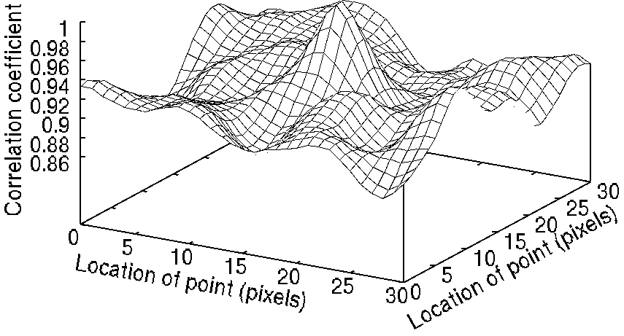

Fig. 1 Relation between correlation coefficient and location of point: note that axis labels should be legible



Fig. 11 Comparison between measured true tensile stress-plastic strain curves and Ludwik relations for base material and FS weld B in transverse(T) direction

Fig. 2 Comparison between measured true tensile stress-plastic strain curves and Ludwik model predictions for base material and FS weld B: note that axis labels should be legible

**3. Conclusions**

We can summarize the instructions for authors as follows:

Fig. 11 Comparison between measured true tensile stress-plastic strain curves and Ludwik relations for base material and FS weld B in transverse(T) direction

Fig. 11 Comparison between measured true tensile stress-plastic strain curves and Ludwik relations for base material and FS weld B in transverse(T) direction

1. This template explains and demonstrates how to prepare your manuscript.

2. Authors are strongly advised to read these instructions to rigorously follow the outline of this text as well as the reference styles for citation.

**Nomenclature** (in alphabetical order)

*c*p specific heat [J/kgK]

*h* heat transfer coefficient [W/m2K]

*ρ* density [kg/m3] (in Greek alphabetical order )

Subscripts (in alphabetical order)

*f* surrounding fluid

*m* mean

##### Acknowledgment

The support provided by the INOUE Science Promotion Foundation, Tokyo, is gratefully appreciated.

## References

[1] Dally, J. W. and Riley W. F.: *Experimental Stress Analysis* (3rd ed.), McGraw-Hill (1990), 374–388.

[2] Chao, Y. J. and Sutton, M. A.: Accurate measurement of two- and three-dimensional surface deformations for fracture specimens by computer vision, *Experimental Techniques in Fracture* (Epstein, J.S ed.), VCH Publishers (1993), 59–93.

[3] Frocht, M. M. and Guernsey, Jr.: Further work on the general three-dimensional photoelastic problem, *J. Appl. Mech.*, **22**–6 (1995), 183–189.

[4] Ohtaki, S., Matsumoto, N. and Kasayama, H.: Photoelastic coating experiment of perforated plate subjected to biaxial tension, *Proc. 12th International Conference on Experimental Mechanics* (2004), 10–11.

[5] Rys, T., Chen, L. and Sankar, B.: Mixed mode fracture toughness of laminated stitched composites, *CD-ROM Proc. 2004 SEM X International Congress and Exposition on Experimental and Applied Mechanics*, (2004).

[6] Sato, Y., Arikawa, S. and Yoneyama, S.: Identification of elastic material characteristics of dissimilar materials by virtual fields method (in Japanese), *J. JSEM*, **14**–24 (2014), 250–256.

[7] Blitterswyk, J. V., Fletcher, L. and Pierron, F.: Characterisation of the interlaminar properties of composites at high strain rates: a review, *Adv. Exp. Mech*., **2** (2017), 3–28.

[8] Longhurst, W. L.: Force control friction stir welding, PhD Thesis, Vanderbild University, (2009).

[9] ImageJ download directory:　https://imagej.nih.gov/ij/download.html

**Appendix**

* Please insert 2 blank lines below the affiliation line on the first page. The information inside the parentheses ( ) is used for filling in the dates of receipt for the original manuscript and the revised manuscript after submission. The final acceptance date will be provided by the *AEM* Secretariat Office.

Fig. 11 Comparison between measured true tensile stress-plastic strain curves and Ludwik relations for base material and FS weld B in transverse(T) direction

Fig. 11 Comparison between measured true tensile stress-plastic strain curves and Ludwik relations for base material and FS weld B in transverse(T) direction